**Mayo Recreation Weekly Schedule – Fall 2016**

**Monday:** Drop-In Soccer – noon – SG

Yoga – 5 pm. – Curling Lounge

**Tuesday:** Drop-In Volleyball – 12:10 - SG

HS Volleyball Practice – 3:30 pm - SG

Circuit Training - 5:30 - FC

Drop-In Badminton - 7 pm. - CH

Floor Hockey – Teen/Adult – 8 pm SG

**j0195704**

**Wednesday:** Volleyball - 8 pm. - SG

**Thursday:** Drop in Kick/Baseball – 12:10 - SG

HS Volleyball Practice – 3:30 - SG

Circuit Training - 5:30 - FC

Floor Hockey – Teen/Adult – 8 pm. SG

**Friday:** Drop-In Floor Hockey – 12:10 - SG

Dinner and Movie Night – 5:00 pm. CH

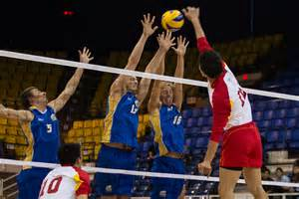 Drop-In Gym – 7:30 - 9 pm. SG

SG = School Gym

CH = Community Hall

FC - Fitness Center

**Upcoming Events**

Soccer Club Registration Deadline – September 22nd

Fitness Trainer Certification – September 23-25

Floor Hockey Tournament in Carmacks – September 24-25th

Dawson City Invitational Volleyball Tournament - October 27-29th

Halloween Events - October 31st

Yukon Volleyball Championships - November 12-14th